Shabbos Stories for
Parshas Vayechi 5773
Volume 4, Issue 15 16 Teveth 5773/December 29, 2012

The Black Plastic Bag
By Rabbi Reuven Semah

“Do kindness and truth with me” (Beresheet 47:29)

There are times we are called upon to do a kindness. Sometimes there is a possible benefit to gain by responding in a positive way and sometimes not. Ya’akob Abinu asked his son Yosef to do him a hesed of emet, a kindness without any benefit to the doer. However, sometimes we think we are doing a hesed of emet, but Hashem has His own plan that there will be a benefit. Sometimes this benefit can be huge.
Rabbi Baruch Brull tells an amazing true story. Chaim and Chavi Weinstein were not people of great means, but they managed. One day they got a call from their close friend Moshe. He needed a loan of $20,000 to invest in a certain product for Pesah and stood to make a big profit.
It just happened that the Weinsteins had a wedding coming up. They were marrying off their daughter and they had just that amount saved for the wedding. They decided that if Moshe could pay it back before the wedding they would lend it to him. Moshe agreed. Now the money was money that Chavi was saving for a rainy day.
For years every time they received a gift she put the money aside. The money was kept in a rarely used room in the basement, wrapped in newspapers and in a plastic bag. Chavi told Chaim to go down and get the money. Chaim went down but couldn’t find the money. They both frantically searched the entire basement and turned up empty-handed. Suddenly Chavi remembered that she just got a new cleaning lady and she told her to clean out the laundry room in the basement. The cleaning girl had come up and proudly told her she “clean out” the entire basement. Both Chavi and Chaim guessed that the cleaning lady took the money. She seemed nice and came with good recommendations, but, who else could it be?
They drove to the other side of town to her apartment. Chaim began, “We know you cleaned the basement today. We are looking for money that we know was there, but it is gone. Did you take it?” “No,” she said. “I never saw any money and I have never taken anything from anyone,” she answered softly, with a hurt expression on her face.
“Well, we are missing a black plastic bag that contained a large sum of money and it is no longer in its proper place in the basement. What did you do with it?” Chaim asked. The cleaning girl gasped, “I cleaned out a room in the basement and found a black plastic bag with old newspapers in it, so I threw it away. If that’s what you mean, it must be with the trash outside.”
They felt bad to have accused her and apologized and started racing home, to see if the garbage men had already come to collect their trash that day. Driving as quickly as he could, Chaim reached their home in time to see their garbage cans still full of trash. Never in their lives did they think that they would be so happy that the garbage men always came late. They opened bag after bag until they found their treasured black bag totally intact and containing all the money. They could hardly believe their good luck.
Exhausted but elated, Chaim looked at his wife and remarked, “Do you understand what just happened? Had we not agreed to lend Moshe the $20,000, we never would have looked for it today and by tomorrow we would never have found it. Because we wanted to do this hesed, Hashem immediately repaid us in cash, in full!”

Reprinted from this week’s email of the Jersey Shore Torah Bulletin.

Good Shabbos Everyone
The Right Number
By Rabbi Binyomin Pruzansky

The gabbai's eyes moved rapidly across the familiar faces of the men packed into shul on this sunny Shabbos morning. Shloime Kaufman, the gabbai, had been going through this routine for the past twenty years, looking out over the congregation and glancing, face by face, at his many friends and neighbors — a world of warm-hearted people with whom he shared his life.
Choosing a few each week for aliyos was a job that came with its difficulties, but it also gave him the weekly opportunity to count these blessings. This secure, contented world in which he found himself was all the more precious because, by any law of logic or probability, it should never have come into existence.
The world Mr. Kaufman had known as a child and young man in Poland had been erased. It had collapsed all around him, snuffing out the lives of his loved ones. At the time, he had thought that surely the few survivors who managed to emerge from the rubble alive would be left with nothing — no yeshivos, no shuls, no gedolim to guide them.
And yet, here he was, the grandfather of a beautiful, Torah-observant family, the gabbai of a thriving shul, surrounded by friends and family. Better to relish the miracle of the present than think too much about the searing pain of the past.
Mr. Kaufman scanned the rows of men as the Torah was removed from the ark. His eyes rested upon an unfamiliar face, a man about his own age with a short grey beard. He hadn't seen him in shul before. He surmised that he must be a guest. But there was something very familiar about this face. Suddenly, the man's features and expression jarred loose a powerful flash of recognition in Mr. Kaufman's mind.
It was Menachem Reiner, his closest childhood friend. It was Menachem, the boy with whom he had grown up in their small Polish shtetl, with whom he had attended yeshivah in Bialystock. It was Menachem, the young man to whom he had clung, and who had clung to him, as they began their cattle-car journey into the fearsome blackness of Auschwitz.
They had promised each other to stick together, they had given each other courage and hope. Bearing the numbers the Nazis had tattooed on their arms, they had found in each other the strength to hold onto their humanity and resist becoming only numbers. They had vowed to help each other survive, both in body and soul. And they did survive, Boruch Hashem.
But when the war ended, each went his own way, eager to begin anew. For sanity's sake, they each tucked the past away into a deep, locked box that would be opened only on rare occasions. Menachem had settled in Israel, and Shloime Kaufman had obtained a visa for America.
Consumed with creating a future and healing the wounds of the past, they had lost touch with each other. That was forty-two years ago. Now, with unbelieving eyes and trembling hands, Mr. Kaufman beheld the unmistakable face of his friend once again.
Shlomie decided in his mind: Menachem Reiner would get the sixth aliyah. As the Torah reading began, the gabbai felt as if his heart could not be contained in his chest. He wanted to leap across the rows of men and fall upon his friend in a mighty embrace. "This must be how Yosef felt when he finally saw his brother Binyamin," he thought to himself. "All these years!"
Nevertheless, he clamped a tight lid on his emotions and performed his duty, calling up each aliyah with the traditional chant of "Ya'amod" followed by the honoree's Hebrew name. By the fifth aliyah, however, beads of sweat were sparkling on his forehead and tears were welling up in his eyes. He prayed that when the time came to call up number six, his voice would be able to break free of his tight throat.
There was no need to ask Menachem his name because he could never forget Menachem ben Yehoshua. For the first time, he began to wonder — how would Menachem react when they came face to face?
It was time to call him up, but Mr. Kaufman could not open his mouth. There were no words fit for this moment. All the suffering locked away in that figurative box was now out in the open, laid out before his eyes, and it was too much to bear.
The congregation began murmuring and looking toward Mr. Kaufman, fearing that the pale, trembling man was becoming ill. A deep cry rose up inside the gabbai — a cry to Hashem that contained in its broken sound all of His children's cries of anguish. Mr. Kaufman turned in the direction of his friend and at last found his voice.
"Yaamod, 57200148!" he called. The baffled men in the shul did not understand what had happened. What was this number? What had become of Mr. Kaufman? But in the back of the room, one man understood completely. The number was Menachem's number, tattooed on his arm as a lifetime reminder of the darkest period of Jewish history, the epic tragedy of his people which he had witnessed with his own eyes.
The entire shul sat in stony silence as Menachem moved slowly toward the bimah. Finally, as they saw him approaching his long-lost friend, they understood the scene that was unfolding in front of them. Menachem needed no introduction. With tears coursing down his face, he cried out, "Shloimele! Shloimele! Is it really you?"
"Yes, Menachem, it's really me!" Mr. Kaufman answered, embracing his friend. They wept into each other's shoulders, rocking gently. "Ay, ay, ay, ay, ay," Mr. Kaufman breathed. Words were powerless to carry his chaotic emotions.
The entire shul sat spellbound, witnessing a moment that could have melted a heart made of iron. As these two men stood together, living witnesses to the Jewish people's miraculous survival, it seemed that the Heavens had opened up to declare, through them, that Hashem would never forsake His people. Am Yisrael Chai!
The Jewish nation is alive, and Torah has been rebuilt in America. The Holocaust survivors who came to America planted the seeds, and it is up to us to reap the fruits of their labor and continue their legacy. (From, Stories for the Jewish Heart - Book 2 R. Binyomin Pruzansky)

Reprinted from last week’s email of Good Shabbos Everyone.

Story #787
The Orthodox-Jewish International Grandmaster
From the desk of Yerachmiel Tilles
editor@ascentofsafed.com

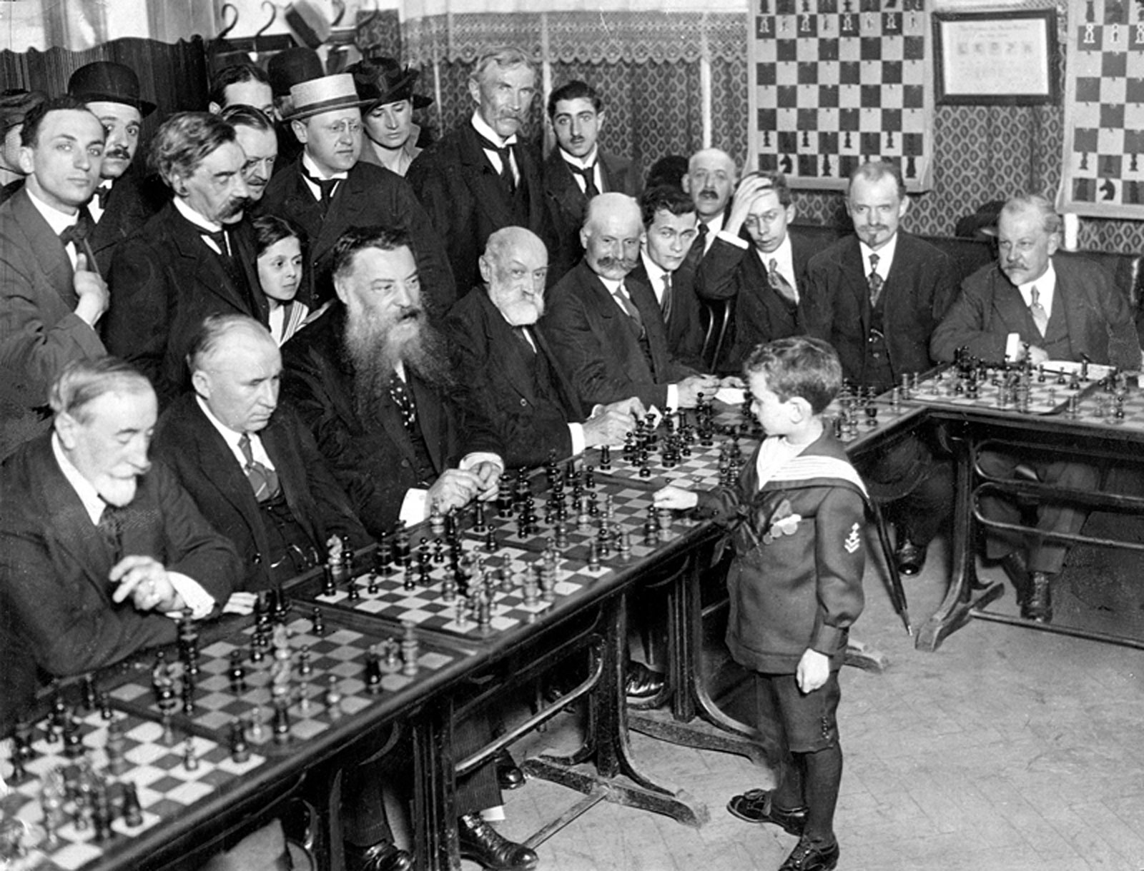
Sammy Reshevsky as a young child playing chess with older competitors simultaneously.

Samuel Herman (Sammy) Reshevsky (1911-1992) was a famous chess prodigy and later a leading American chess Grandmaster. He was born in Ozorkov, Poland in 1911, to parents who belonged to the Gerrer Chassidic dynasty.
When he was nine years old his family moved to the United States, where he later became a contender for the World Chess Championship from about the mid-1930s to the mid-1960s; coming equal third in the World Chess Championship 1948 tournament, and equal second in the 1953 Candidates Tournament. He was also an eight time winner of the U.S. Chess Championship.
Reshevsky was famous for his slow and thoughtful moves, contemplating every move and strategizing every step, sometimes for hours. At the age of six, he already could play against as many as 30 players at a time, moving quickly from board to board and could remember and repeat all 30 games afterwards, move by move.
At the age of eight, he competed against older contestants and won. He was featured in newspapers and branded as a chess prodigy. He was known as "Shmulik der vunder kind"-Samuel the wonder child. He was a descendant of the rabbinic genius, Rabbi Yonasan Eibshitz, who descended from the great Kabbalist, Rabbi Isaac Luria, the Arizal of Tzefat.
Sammy Reshevsky grew up in an observant home, and throughout his life and fame, remained faithful to his Judaism and Torah, refusing to ever play chess on the Sabbath or Holidays.
In the years before his marriage, Reshevsky developed a relationship with the sixth Lubavitcher Rebbe, Rabbi Yosef Yitzchak Schneersohn.
Reshevsky once asked Rabbi Yosef Yitzchak for his blessing for success in a particular chess match. The Rebbe responded that he would grant his wish if he would resolve to study Torah every day. Reshevsky readily agreed, and indeed, the blessing the Rebbe granted was fulfilled.
Living in Crown Heights in the 1940's, Sammy prayed in the central Lubavitch synagogue at 770 Eastern Parkway in Brooklyn, NY. Once, at a Sabbath gathering (farbrengen in Yiddish), in 1948, the Rebbe, in recognition of his presence, explained the spiritual meaning behind the chess game.

Later in Life
Upon turning 70 and no longer on top of his game, Sammy Reshevsky asked the Lubavitcher Rebbe, Rabbi Menachem Mendel Schnnersohn, if he should retire. The Rebbe advised him to continue playing because it was a "Kiddush Hashem"-a sanctification of G-d in the world, a proud demonstration of a Jew succeeding without compromising his spiritual ideals and values.
Reshevsky complied and shortly afterwards, he traveled to Russia and upset the world champion at that time, Vassily Smyslov. He received a standing ovation from the thousand-member audience who were enchanted by his brilliance.
On a side note, here is an interesting tidbit: in 1984, the Lubavitcher Rebbe requested Reshevsky to try and help his colleague Bobby Fischer get out of his world-famous depression and isolation, and also to help him in relation to his Judaism.
Bobby had already been out of public life for a few years, and was known to be living reclusively in Los Angeles. Soon after Reshevsky received the Rebbe's letter, he traveled to Los Angeles to play at a tournament. As soon as he arrived, he phoned Bobby and related the Rebbe's request to him.
Bobby immediately agreed to see him. This was very unusual, since he did not often receive visitors. Their meeting lasted three hours, during which Bobby asked many serious questions about Judaism. Original article written by Rabbi Y. Y. Jacobson (//yeshiva.net).
Supplemented by Ascent from an article on // chabad.org (528301) by Dovid Zaklikowski.
Reprinted from this week’s email of KabbalaOnline.org, a project of Ascent of Safed. www.ascentofsafed.com ascent@ascentsafed.com

The Chess Game
Based on an Explanation by
Rabbi Yosef Yitzchak Schneersohn
The Sixth Lubavitcher Rebbe
There is one king. All of the other pieces revolve around him and their entire mission is to protect and serve him. G-d is the King, all else was created by Him, given the opportunity to connect to His truth and to serve Him.
The queen represents the feminine manifestation of the divine, known as the "shechinah," intimately involved with every aspect of creation, granting vitality and substance to every existence. The queen is the most practically affective piece, often sent into the lines of fire, even placed in danger. Likewise, G-d risks His own dignity, as it were, by investing Himself in every creature and existence, subjecting Himself to the vicissitudes of the human condition.
Then there are bishops, rooks, and knights. They are swift, free, not limited by the squares immediately surrounding them; they can "fly" around freely, without constraints. These are symbolic of the angels-in their three mystical categories we discuss in the daily morning services, "seraphim," "chayot" and "ofanim," represented by the bishops, rooks, and knights.
In order for there to be free choice in the world, there are two teams, the white and the black. One team representing G-dliness and holiness; the other team representing everything antithetical to G-dliness and holiness. The teams are engaged in fierce battle. And for the confrontation to be meaningful each team contains, at least on the surface, all the properties contained in the opposite team. Both teams pretend to have a king, queen, bishops, rooks and knights.
Finally, there are the pawns. They are very limited in their travel, moving only one step at a time, only in a singular direction, and they constantly get "knocked off." But... when they fight through the "board," arriving at their destination, they can be promoted even to the rank of the queen, something that the bishop, rook or knight can never achieve.

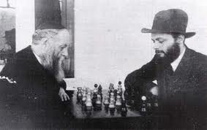
Rabbi Yosef Yitzchak Schneersohn and his son-in-law, Rabbi Menachem Mendel Schneerson playing a game of chess.

The pawn represents the human being living down here on earth. We humans take very small steps, and we are so limited in every aspect of our journey and our growth. We also constantly make mistakes and get "knocked down."
But when man perseveres, and overcomes the angst and despair of his or her own failings and mortality, when we fight the fight to subdue darkness and to reveal the presence of the "king" within our own bodies, our own psyches and the world around us-the human being surpasses even angels; the pawn is transformed into a queen! The human life reunites with its source above, the queen, the Shechinah, experiencing the deepest intimacy with the King Himself.
The bishops, rooks, and knights, though spiritually powerful and angelic, are predictable, and limited by their role. There is no room for real promotion, no substantive growth, no radical progression. Yes, they fly around, but only within their own orbit. The angels on high, as well as the soul alone on high, before entering the body, are powerful yet confined by their own spiritual standing.
It is the limitations of the human person that stimulate his or her deepest growth. The limits of our existence create friction, causing us to strain against the trials and disappointments of life.

A Moment with Rabbi Avigdor Miller, Zt”l

Why Are Some People
Afraid of Marriage?

ANSWER:
Everybody should be afraid of marriage. Marriage is like life, and life is more to be feared than marriage. Life is full of risks. You walk out on the street, you have to know that immediately you are surrounded with lunatics, with criminals, and with fools. It's only by being very careful not to get involved with anybody on the street that you can survive. If somebody says something, don't pay any attention, be polite. If something happens, try to pass by as quickly as you can. You must steer your way in the street to avoid the many pitfalls, and still you go into the street. You have to go.
Marriage is less dangerous. In marriage of course you must guard your tongue, of course you must be patient, of course you have to adjust yourself to another person. People think that the main problem of marriage is marrying the right party. No. That is something you have to do.
But the main problem of marriage is, being the right party. And that has two parts, one part is preparing for it. You have to learn how to be a mentch before you are married, so it means you you'll marry when you're 99 years old? You have to learn how to be a mentch as early as possible.
A mentch also means, you have to work. You have to learn how to work to support a family, or you have to be a learner, but to be a nothing, you don't deserve a wife, and you don't deserve a life either. To live in this world you have to do something.
When a man postpones marriage because of fear, he's making a major error. Because time is passing by and the older he gets the less suited he is for marriage because he becomes more fixed in his ways, in his bachelor habits, and it'll be more and more difficult for him to adjust. When you're young and pliable, then it's easier for you to change yourself in order to fit in, in the pattern of marriage.
Therefore to be afraid of marriage, is natural, but it should never deter somebody from doing what his duty is.

Reprinted from last week’s email of “A Moment with Rabbi Avigdor Miller, zt’l” that is based on a transcription of Rabbi Miller’s answer to questions posted to him by members of the audience attending his classic Thursday night hashkafah lecture in his Flatbush shul circa 1970’s – 2001.

The Voice of History Rabbi Berel Wein's Compelling Views on Jewish Destiny (Part 1)
By Rabbi Shraga Simmons

Rabbi Berel Wein is the history teacher of an entire generation. Whether describing Israel’s lightning-swift victory in the Six Day War or the Holocaust, the Medieval Crusades or the biblical account of Creation, Rabbi Wein captures the drama of events and puts them into global perspective.

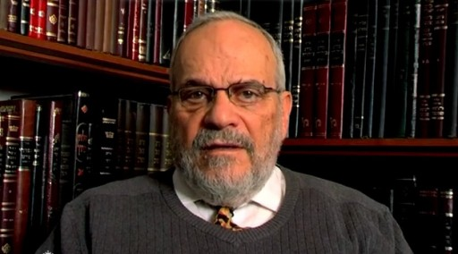
Rabbi Berel Wein

His prolific output includes 1,000-plus audio lectures, four-volume series of coffee table books, and more recently the Destiny Foundation films on the life of Rashi and Maimonides (narrated by Leonard Nimoy), plus a history of Jews in the 20th century, “Faith and Fate.”
Raised in Chicago and trained as a lawyer, Rabbi Wein “heard the calling” and became a driving force in American Jewry for four decades – as synagogue rabbi, kashrut administrator, lecturer, author and Rosh Yeshiva. In 1997, he packed up and fulfilled a lifelong dream of settling in the Holy Land. With keen insights and innovative approach, coupled with a dry and endearing Midwestern humor, Rabbi Wein continues to inspire tens of thousands.
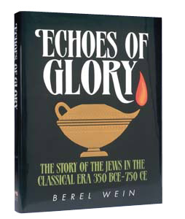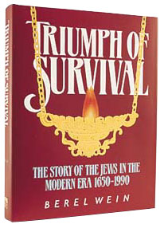

Aish.com spoke with Rabbi Wein at his home in the Rechavia neighborhood of Jerusalem.
Aish.com: What makes you so passionate about history?
Rabbi Wein: I had a friend who made picture frames. I’m not talking $5 in Walmart; these were $250,000 frames for Rembrandts hanging in museums. The difference between seeing a painting on canvas and seeing it in a frame is enormous. When it comes to current events, history is our framework.
Today it’s 30-second sound bites and therefore we’re blindsided by current events. We don’t realize that we’ve been through this before. In the past, some of our actions proved successful; others were not. The more we’re informed about our history, the more wisdom we have for living today.
Aish.com: It’s been said that the story of the Jewish people is the most incredible in all of human history. What makes Jewish history so unique?
Rabbi Wein: Jewish history teaches us faith, evidence of God’s existence. If you see how the Jewish people have survived over the ages – against such enormous odds, how we’ve remained resilient, and how we’ve repeatedly rebuilt ourselves – you have to stand back in amazement. You know there is something special about the Jewish people.
Jews need to know their special story. Because if you feel special, you act special. And acting special is pretty much the definition of being a good Jew.
Aish.com: Why is there such an ongoing failure to learn from history?
Rabbi Wein: In much of the world, history is not taught at all, except as an academic subject for those who are interested. Or it’s taught in a boring fashion – dry facts and dates. If I tell you the Battle of Hastings was in 1066, what’s that got to do with my own life? If there is no personal connection, I’m going to tune out.
A dynamic approach to history says: I’m not telling you about past events; I’m telling you something about yourself. The Torah itself says: Zeh sefer toldos Adam – “This is the book of human beings” (Genesis 5:1). Our Torah is not a history book; it’s a guide to yourself. Every Jew needs to know how he is personally affected by the Romans, the Greeks, the Holocaust, immigration to America, the State of Israel.
If a person can identify in those terms, then history becomes fascinating. Otherwise, it’s just a date and a place. And a person can go through life thinking that the world began in Phoenix where he was born.
Aish.com: What seems to survive best are the stories and legends of great historical figures.
Rabbi Wein: After biblical times, not all legends about previous generations are literally true. Not everyone was an angel but they were all human beings. There's a great danger in making the previous generations out to be angels: That doesn't impact my life, since I'm not an angel nor is my goal to be an angel.
It sets a bar so high that it becomes irrelevant. But if you say that the previous generations were human beings who struggled against their flaws, then I look at myself and say, “They were human beings, so why am I behaving like a donkey?”
My father-in-law grew up in the house of the Chafetz Chaim [the leader of European Jewry in the early 20th century]. The Chafetz Chaim, as a Kohen, was short-tempered. But when he felt himself getting angry, he walked into a corner of the room until he talked himself out of it. To me, that’s much more impressive than to say “he never got angry.” It’s something I can emulate. I can rise to the challenge.
Aish.com: You are a great advocate of studying the biblical prophets. Are there certain episodes or characters that you see being reflected in today’s reality?
Rabbi Wein: I think the books of Shoftim and Shmuel are really the newspaper of our time. Ein melech b’Yisrael – there’s no strong leadership. Everybody thinks they can do their own thing. But God conspires to have certain individuals arise to save the people – the prophet Samuel, King Saul, King David.
These were all unlikely leaders. Shmuel was never supposed to be born because his mother was barren. Shaul was hiding, looking for a donkey. David was the youngest brother. The most unlikely candidates are the ones that God chose.
We have to be more receptive to what God wants. When people arise with new ideas, we should not necessarily see them as negative. They may be messengers from Heaven.
For example, it’s interesting that the State of Israel was founded by secular Jews. If it would have been founded by religious Jews, chances are the masses would not have rallied to it, and it would not have become what it is. I can’t read God’s mind, but that’s my gut feeling.
In the early 1940s in Chicago, Rabbi Wein’s grandparents watched their pennies and saved up enough money to paint the interior of their modest home. Finally the big day arrived, but that morning the grandparents received news from Europe of the deportation and mass murder of Jews. Young Berel watched intently as his grandfather phoned the painter and said: “We’re canceling the job, and we’ll pay you the money anyway.” He then turned to his wife and said: “How can one make his house fancy when Jews are suffering so much?”
Aish.com: Anti-Semitism has been such a pervasive, constant theme in Jewish history. What is its primary cause?
Rabbi Wein: It morphs and mutates. The original anti-Semitism in Greek and Roman times was nationalistic. It wasn’t religious, because they were pagans who had 100 gods and didn’t care if you added another one. What bothered them was the exclusivity of the Jews, the national entity that refused to integrate. This became especially true when the Jews fought in wars and rebellions against the Greeks and Romans. War always brings great animosity not easily forgotten.
Things changed when Christianity came into the world. Christianity was and is bothered by Jewish obstinacy in not accepting the so-called Jewish Messiah. That became religious anti-Semitism, and the mere fact of Jewish survival presented a challenge, especially to the Roman Catholic Church.
As the church waned in more modern times, things morphed into racial anti-Semitism, a “problematic DNA” within the Jews. Religious anti-Semitism can be solved by converting, but if it’s in your bloodstream, there’s nothing to do about it. The culmination of this, of course, was the Holocaust with its racial doctrines.
Also in our time we’ve seen ideological anti-Semitism. No matter how many Jews profess loyalty to Communism or any of the so-called progressive ideas, Judaism always presents a barrier. Jews could never be fully accepted as “good” Communists.
(To be continued next week)

Reprinted from this week’s email of the Aish.com website.

Driving Home
From Newtown
A Call to Action from Sandy Hook
By Aviva Deren

Until this weekend I had never heard of Noah Pozner, or of his family. But Noah’s father, Lenny, has a friend, and the friend had heard of us and called.
“They need you. You can speak to them, you can relate to them. Come, please come.”
There isn’t much to say to a request like that. I knew why we had been called. It was not only because my husband is a compassionate and caring rabbi, who has brought comfort to so many hurting people.
We were being asked to help because as bereaved parents ourselves, several times over, perhaps we had something more to offer—if only to be evidence that it is possible to breathe after the breath has literally been knocked out of you.
With much trepidation, I traveled with my husband to the house where the Pozners were. I walked in with a prayer on my lips that whatever we say will bring comfort, and not, G-d forbid, add to the unbearable burden these people were already carrying.
We were brought to a quiet room, away from the hustle and bustle, to speak with Noah’s family. I found myself listening to a brokenhearted mother describing her little boy, Noah, one of the first-graders at Sandy Hook Elementary School in Newtown, who was the youngest of the victims in the shootings last Friday. Those are, and should remain, private conversations, the kind of conversations that no one should have to have, ever.
What I do want to share are some thoughts that came to me as the day wore on.
Noah. The themes of the biblical story kept playing in my mind. Noah. Someone described in the Torah as a tzaddik, a righteous person, “complete.” All of humanity are considered to be his descendants, bound in a covenant with G-d, to partner with Him to create a world of peace and harmony, of justice, goodness and kindness. The almost universal symbols of peace, a dove and an olive branch, trace back to Noah and his story.
Lenny’s friend is not Jewish, but he is passionately committed to the Noahide Code, the covenant that the Torah teaches was entered into by G-d and Noah after the Flood, a covenant that binds G-d and Noah’s descendants for all time. These universal commandments are the antecedent of any formal religion.
The Noahide code is based not on clergy or houses of worship, but on the covenant between the Creator and humanity, the foundation for all human endeavor. Seven principles, seven commandments, that if they were implemented would bring about a virtual utopia of human existence.
“Noah loved rainbows,” his mother is telling someone. Rainbows! The sign of G-d’s promise never, ever to bring a flood on the whole world again. A symbol of healing, promise, and optimism.
We have moved to the high school, where the president is going to meet with each of the families. Governor Malloy and his wife, Cathy, come into the room first. The governor speaks gently with each family member. He embraces my husband warmly, turning to the family—“This is my very good friend.” They speak briefly about how we go forward after this overwhelming tragedy. The governor asks my husband to be in touch within the next 24–48 hours.
The president enters with no fanfare or even an announcement, and without being told to do so, everyone rises. I am moved to tears watching him with these grief-stricken people. The power of this gesture is immense; he truly does convey the sense that the whole country is mourning alongside these anguished families. The way he bends down to speak with Noah’s twin sister, the way he comforts the grandparents and gently joshes the teenage siblings, the way he makes a point of saying, as he did later, that “we will be with you,” not just now, but for the long haul. The president met privately with every single family, and took time to speak at length with each bereaved parent.
Noah’s family did not stay for the vigil; we left the high school with them and the caring, close-knit circle of family and friends that surround them so tightly. On the way home, we listened to the president. I found his speech stirring, and even more than that, heartfelt.
There was an authenticity in this speech that one does not often encounter in public life. In my opinion, the speech was simply magnificent. I hope that every classroom in our country will study those words and figure out how to translate them into real life. I hope that adults will hold those same conversations.
Most of all, I feel that his words were a call to action to all of us, to access the best within us individually and as a country, to really, truly, once and for all do what has to be done so that our world is a place where things like this can never happen again. To take those words of “never happen again” out of the fairy tales and put them where they can make a difference.
Late in the afternoon it hit me: We need a flood! Not, G-d forbid, a destructive flood—we’ve had more than enough of that. What we need is a good flood—a flood of kindness, of caring, of compassion, of goodness, of warmth, of benevolence, of support, of reaching out.

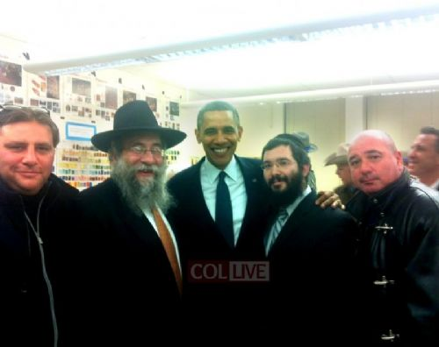
Rabbi Yisrael Deren, left of President Obama, Rabbi Sholom Deitsch

There are, thank G-d, enough of us on this planet to make sure that not one human being ever feels lost. We need a flood of connections. Not just the trickles that come from time to time, but everywhere, all the time. We need to be at least as aware of the ecology of human behavior as we are of the ecology of the physical resources of the planet.
It has to penetrate all aspects of our world—the worlds of business, the media, education, culture, science, the arts, medicine—we need a flood, a good flood. Every single one of us has to know that we can make a difference, and we need to put serious thought to how we can best do that. “Noah’s Flood” could take on a whole new meaning.
My husband made a suggestion to the president, that in the effort to draw good from the unfathomable evil that occurred we should offer a “moment of silence” at the beginning of each school day. This “moment of silence” will allow those children who want to pray the opportunity to do so; it will foster discussion between parents and children of the spiritual values they hold dear as a family.
This suggestion was first made years ago by the [Lubavitcher] Rebbe, who always held the clear vision of a world perfected by the partnership of G-d and human beings.
And here, Mr. President, if I may respectfully offer one change—no, make that one addition—to your words. Yes, G-d has taken them home. But now it’s time for the rest of us to make sure that G-d’s home is right here on earth; to make sure that we, all of us together, bring heaven down to earth.
And Newtown will then forever be known as the place where light triumphed over darkness, the place where the healing of our aching world finally began for real.

Reprinted from this week’s email of Chabad.Org Mrs. Shifra Aviva Deren is co-director of Chabad-Lubavitch of Connecticut and Western Massachusetts. With a passion for education, Mrs. Deren is the founding director of the award-winning Gan Yeladim Early Childhood Center in Stamford, Connecticut. She is a sought-after speaker on the role of women in Jewish life, and a mentor to many.

